**LAB – 5: - Introduction to AWS IAM (Identity and Access Management)**

Name: Naren Chandrashekhar

SRN: PES2UG20CS216

Section: D

Screenshots

● user-1 added to the S3-Support Group.

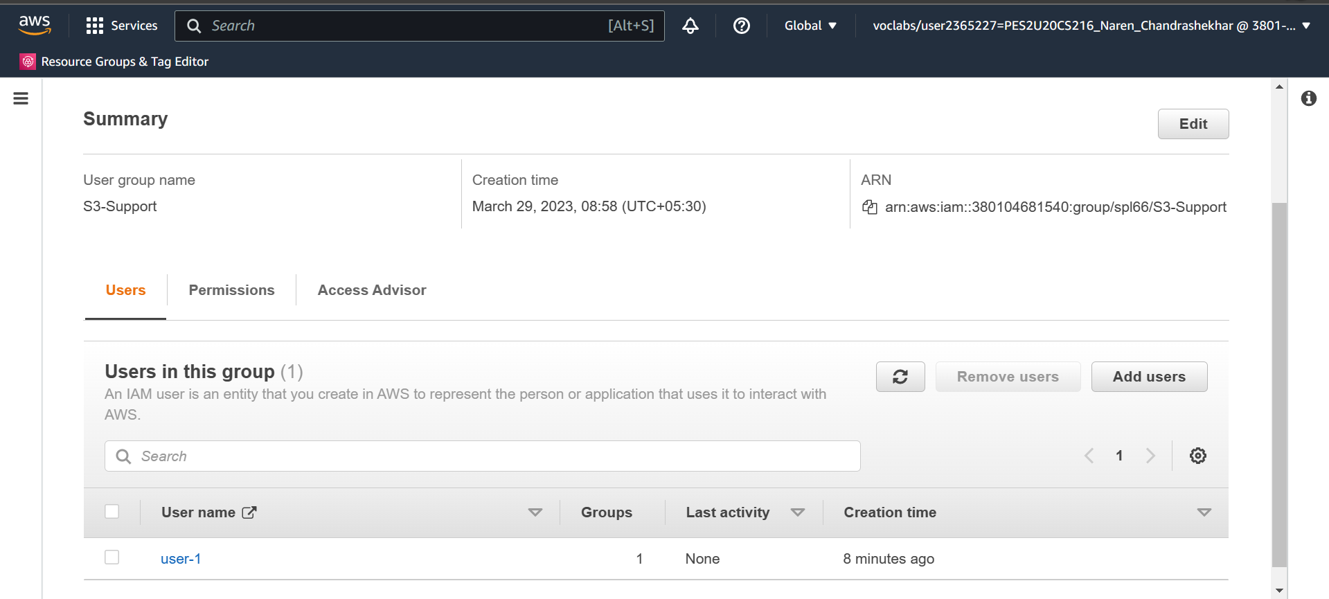

● user-2 added to the EC2-Support Group.

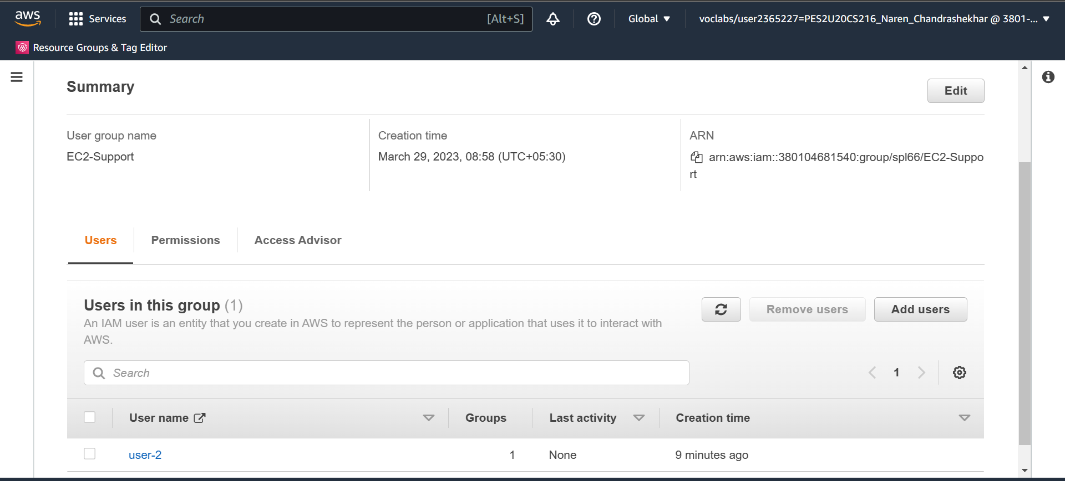

● user-3 added to the EC2-Support Group.

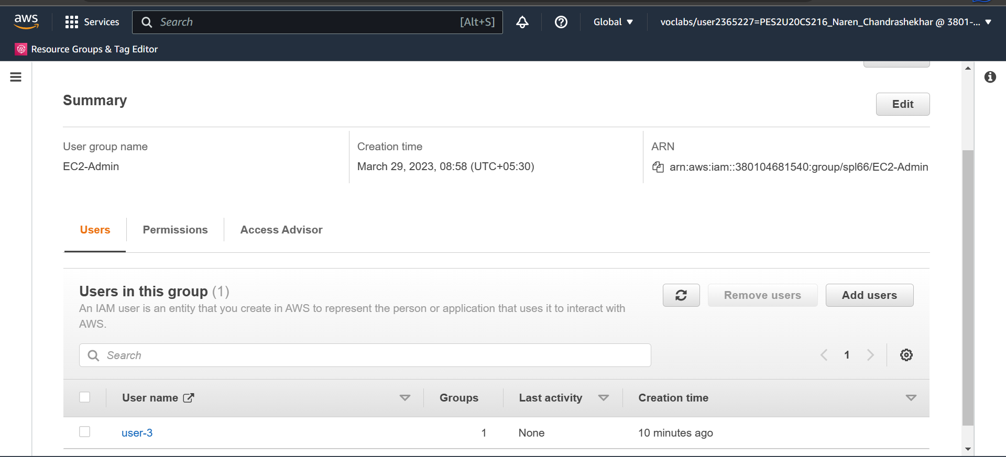

● View S3 buckets with user-1 role

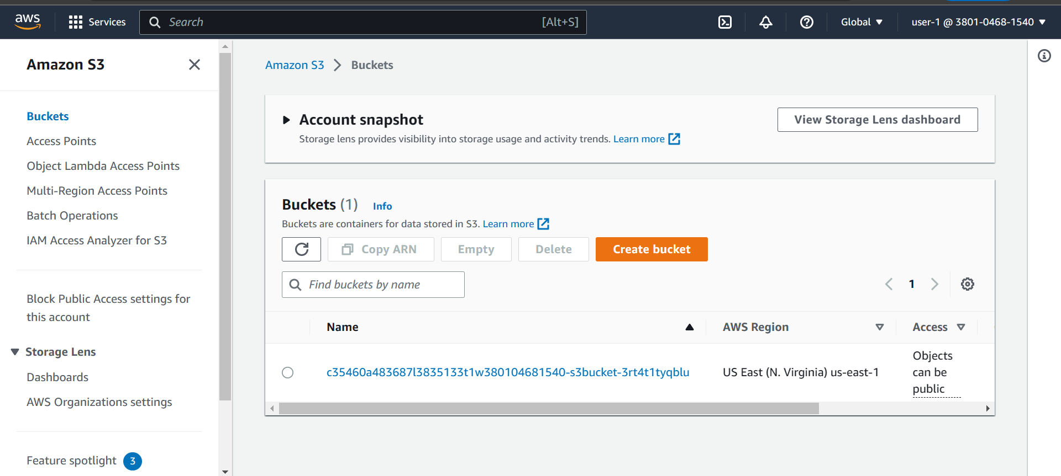

● EC2 instance dashboard with user-1 role (Not authorized)

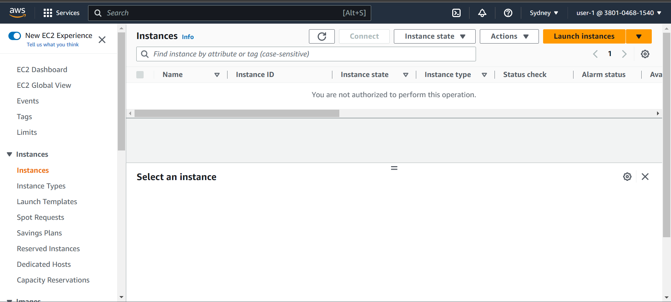

● Failure message when instance stopped with user-2 role

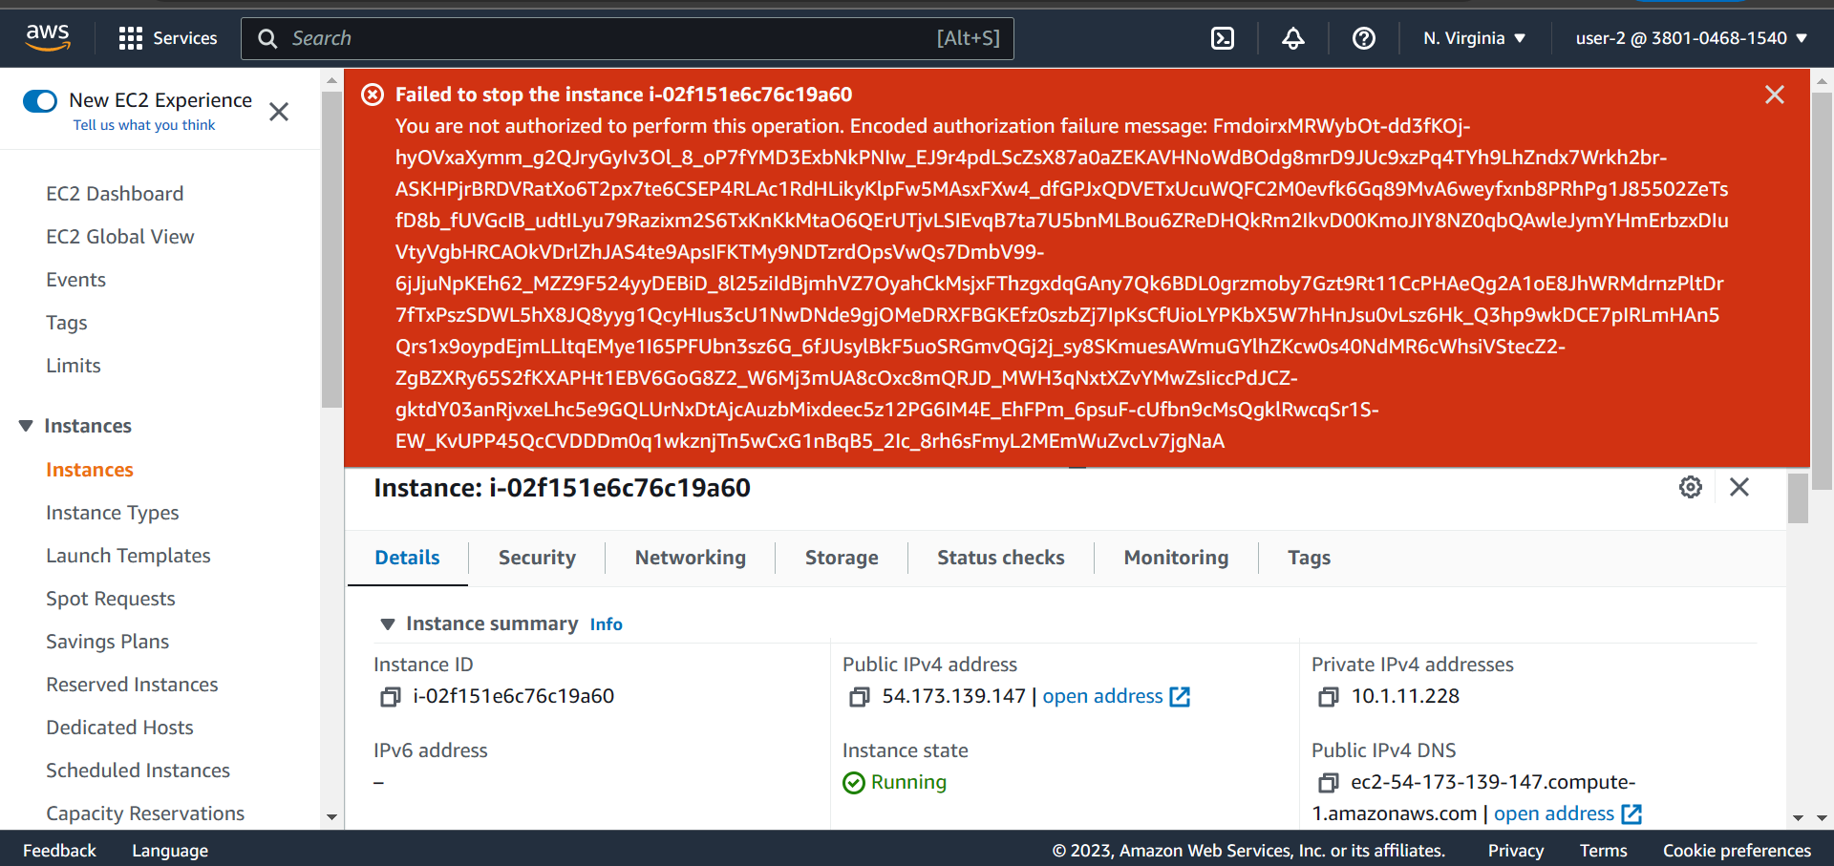

● Successful stoppage of E2 instance with user-3 role

